Rafal Szymanski

GMCA5  MySQL Day2

GMCA5 MySQL Day2

Table of Contents

EER Diagram for world database 2

Identify the primary key in country table 2

Identify the primary key in city table 2

Identify the primary key in countrylanguage table 2

Identify the foreign key in city table 2

Identify the foreign key in countrylanguage table 2

# EER Diagram for world database

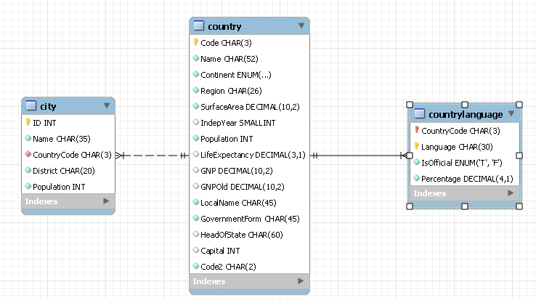

# Identify the primary key in country table

CODE

# Identify the primary key in city table

ID

# Identify the primary key in countrylanguage table

CountryCode

# Identify the foreign key in city table

CountryCode

# Identify the foreign key in countrylanguage table

CountryCode